

Head of Estates
Recruitment Pack
Apri 2025

Team: | Estates
Contract Type: | Permanent
Hours: | Full Time
Salary: | £55,000
Location | Chichester

About Chichester Cathedral

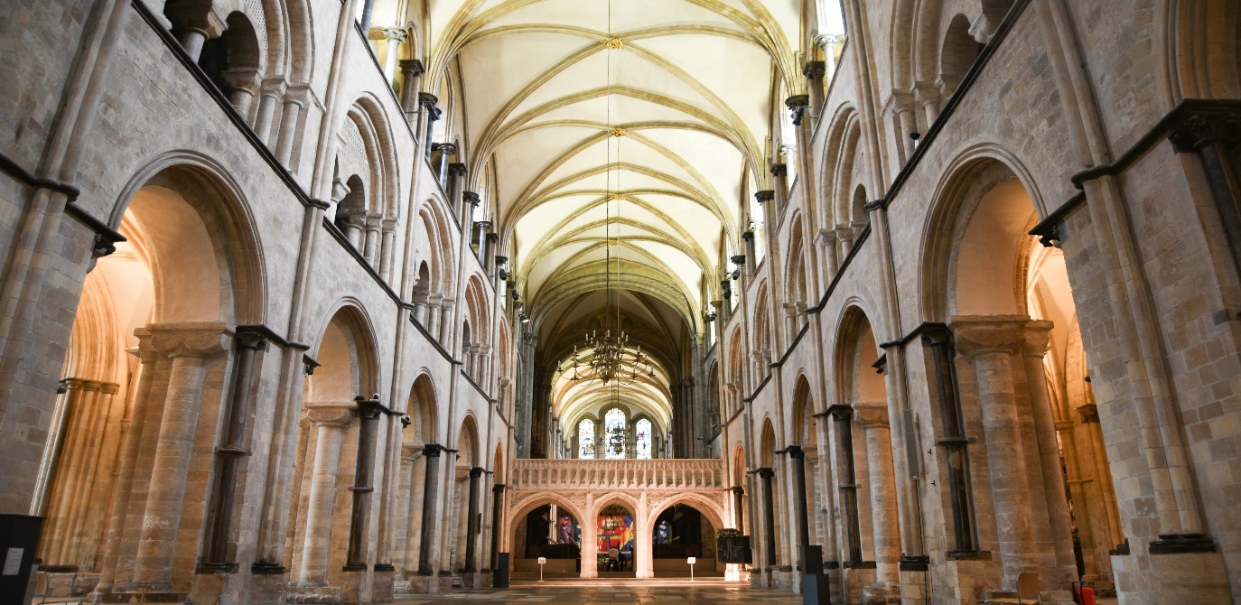
The Cathedral is a living church that has been at the centre of life in Chichester for over nine centuries. We are a place of worship and mission, the Mother Church of the Diocese of Chichester (which covers East and West Sussex) and the seat of the Bishop of Chichester. We are supported by a committed worshipping congregation, a small but dedicated staff team and over 400 volunteers.  The Cathedral is a leading visitor attraction, a venue for artistic and cultural activity, and an all-round hub for the community, welcoming over 250,000 visitors each year. Music is a central element in the Cathedral’s life. The choir, which offers eight sung services each week and contributes to the Cathedral’s outreach around the diocese, has a high reputation at national and international level. We also host many high-quality musical performances each year by choirs, orchestras and chamber groups. | The Cathedral presents a comprehensive events programme and has a trading subsidiary, Chichester Cathedral Enterprises Ltd (CCEL), offering hospitality and retail services that support the Cathedral in delivering its mission. We have both a residential and commercial property portfolio many of them listed, in the Cathedral Close and beyond.  The Cathedral does not receive statutory or Church of England funding and is self-supporting, relying on self-generated income, donations, and fundraising activities. The Chapter is supported by the Chichester Cathedral Restoration & Development Trust and the Friends of Chichester Cathedral.  Further information about Chichester Cathedral can be found on the Cathedral website, including our Annual Report & Accounts.
Welcome from the Dean

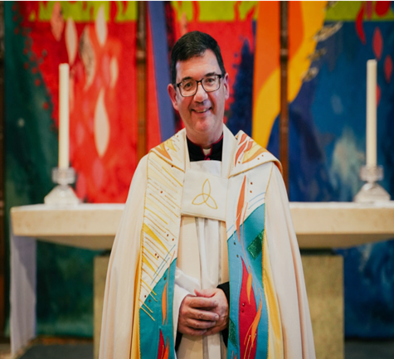

Thank you for your interest in the role of Head of Estates at Chichester Cathedral.

This year the Cathedral celebrates its 950th anniversary. We are proud of our wonderful heritage of buildings on the Cathedral estate, and conscious of our responsibility to maintain these as living buildings, maintained to a high standard, and serving a large number of people into the future.

The Head of Estates will play a key role in ensuring that we can do this, and we look forward to welcoming the person who is appointed into a strong and supportive team.

Very Reverend Edward Dowler
Dean of Chichester Cathedral
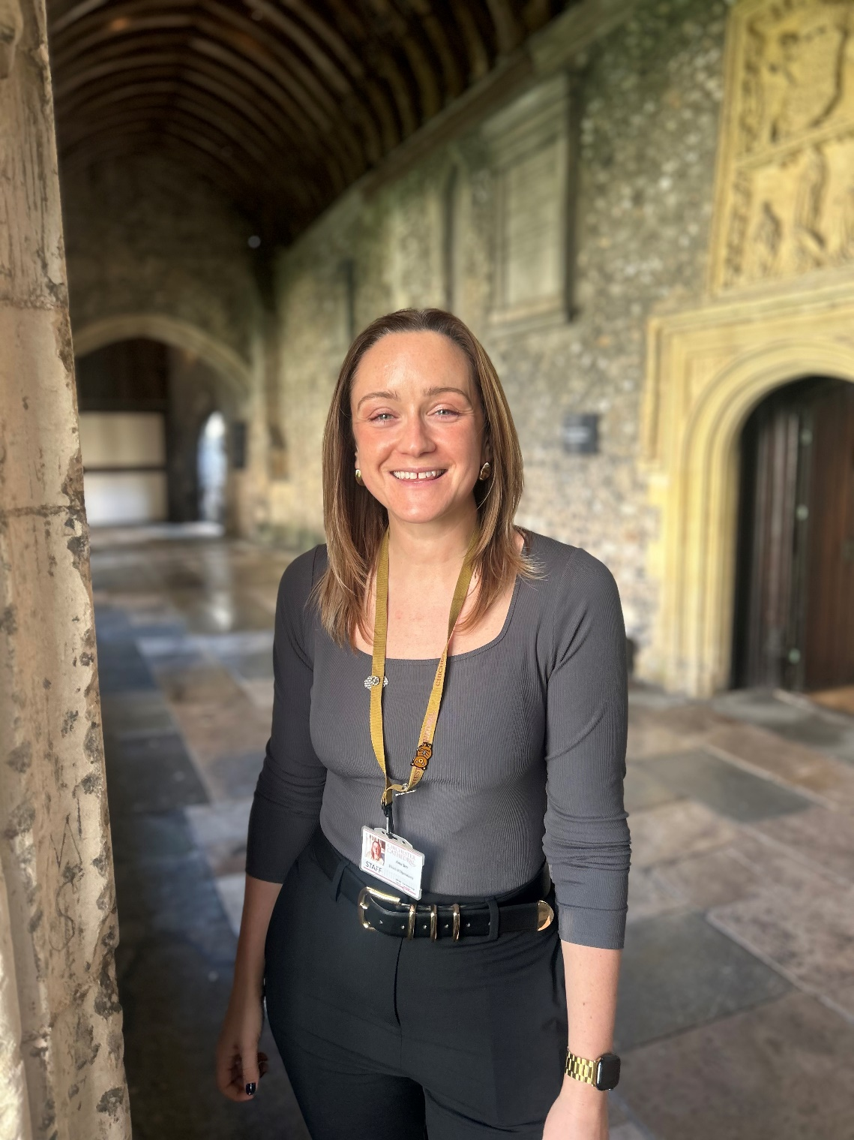
Welcome from the Communar
Thank you for your interest in the role of Head of Estates at Chichester Cathedral.

This is an exciting time to join our small, dedicated team as we look to the future with ambition and purpose. Every member of our team plays a vital role in preserving our extraordinary heritage while helping us to thrive in a rapidly changing world.

The Cathedral stands at the heart of the city – a place of worship, history, creativity, and community. The estate we care for is rich in architectural and historical significance, and this role is pivotal in helping us to unlock its potential. We are looking for someone who combines practical experience with strategic vision: a skilled professional who can ensure our estate is safe, compliant and well maintained, while also identifying opportunities to generate income, improve sustainability, and support the Cathedral’s wider mission.

You will be joining a committed and collaborative team, where your ideas will be valued, and your work will have real impact. Whether it’s managing conservation projects, developing new ways to use our spaces, or delivering environmental improvements, this role offers a unique chance to shape the future of an exceptional and much-loved place.

If you have a passion for heritage, a sharp eye for operational delivery, and a heart for sustainability, we’d love to hear from you.

Amy Sim
Chief Operating Officer & Communar
Commitment to Safeguarding

In accordance with Church of England’s policy, Promoting a Safer Church and the House of Bishops’ Safeguarding Policy and Practice Guidance, Chichester Cathedral is committed to the safeguarding of children, young people, and vulnerable adults who may be at risk.

The Cathedral works in partnership with the Diocese of Chichester to ensure that we operate in accordance with best practice at all times.

The care and protect of children, young people and vulnerable adults are the responsibility of the whole Cathedral community, whether clergy, staff, volunteers, contractors or members of the congregations. Everyone who participates in the life of the Cathedral has a role to play in promoting a safe environment for all.

To learn more about Safeguarding at the Cathedral please see our website.

Commitment to Equality & Diversity

At Chichester Cathedral we are dedicated to encouraging a supportive and inclusive workplace culture amongst our employee and volunteer workforce. It is our aim to ensure that if you work here or apply to work here, on either a paid or voluntary basis you will have an equal opportunity. We are also committed to working towards an organisation workforce that is diverse and as representative of our wider community as it can be.

We respect and value each of our employees and volunteers and are committed to enabling you to be able to perform to the best of your abilities and to be your authentic self in the workplace.

About the Role

The Head of Estates vacancy has arisen because our current post-holder is looking forward to their retirement. The Estates team comprises two maintenance staff who ensure that our Cathedral estate is maintained to an excellent standard and an Estates Co-ordinator who looks after the administration including budgets but has also plays a key role in our Eco Church gold award.

The Head of Estates will also be joining an enthusiastic management team who work together to ensure that the Cathedral’s operations are as effective as they can be.

This is our 950th anniversary year and we are seeking a Head of Estates who can bring fresh ideas and initiative to enable us to manage our Cathedral estate and also manage our commercial and residential property portfolio as effectively as we can.

A copy of the job description is here, if you believe that you have the skills and experience that we require, we look forward to receiving your application.

If you would like a conversation about the role before you apply, please email our Chief Operating Officer at: amy.sim@chichestercathedral.org.uk to arrange a time to speak.

How to apply

You are required to complete an application form, available on our website: here

Please email your completed application to: Val Timlin, our Head of HR at:
val.timlin@chichestercathedral.org.uk

The closing date for applications is 9.00am on Tuesday 13 May 2025
.
Interviews will take place in Chichester on Thursday 29 May 2025

Any questions about the process?
Head of HR, Val Timlin
val.timlin@chichestercathedral.org.uk

