Liturgy & Music Co-ordinator
Recruitment Pack
June 2024

Team: | Liturgy & Music
Location: | Chichester Cathedral
Contract Type: | Part time, permanent
Hours: | 28 hours per week worked over 5 days
Salary: | £20,000 [FTE equivalent: £25,000]

Any questions?
Head of HR, Val Timlin
hr@chichestercathedral.org.uk

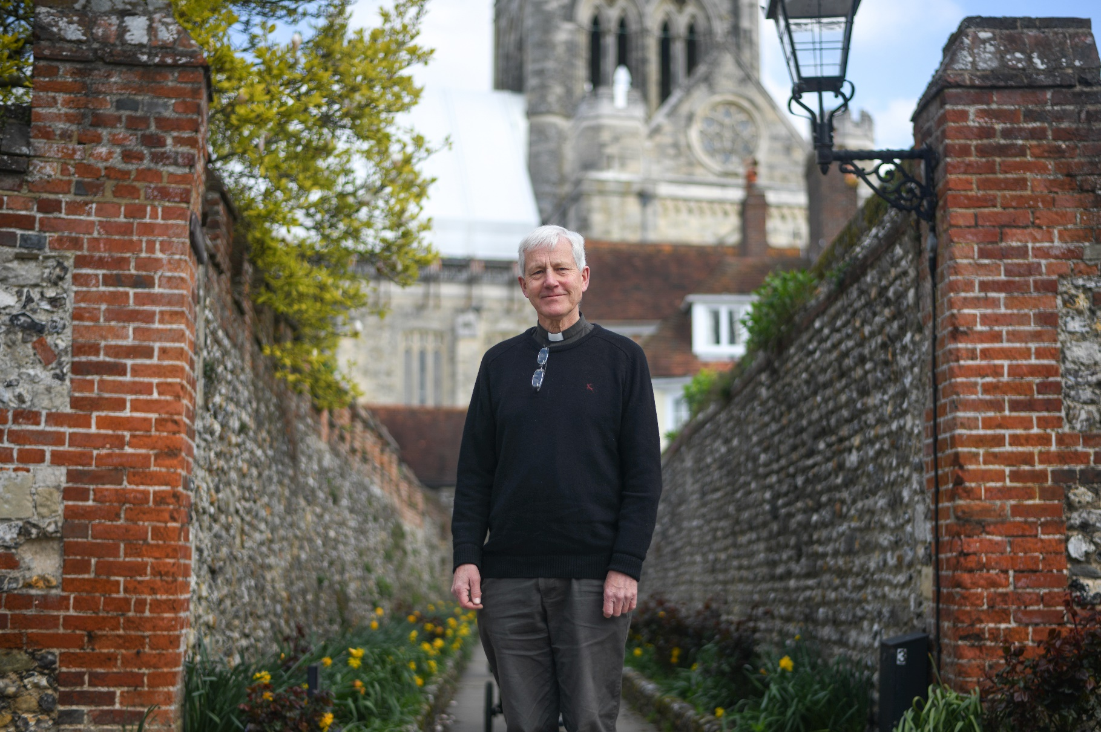

Welcome from the
Interim Dean of Chichester

Dear candidate
Thank you for your interest in the post of Liturgy & Music Co-ordinator at Chichester Cathedral.
The Cathedral is right at the heart of the city of Chichester and attracts many visitors and tourists. It has a rich liturgical tradition and a superb choir and hosts many cultural events. It has a strong congregation, including a growing number of families, and a close relationship with the Prebendal School, where the Choristers are educated. It also has a long history of engagement with the arts and supports a unique Workshop for Liturgical Art.
The Cathedral Chapter is seeking a Liturgy & Music Co-ordinator who will have responsibility for, amongst other things, ensuring the effective administration of our services and events, further details are in the job description below.
The Cathedral is at an exciting time in its history. We have recently welcomed a new Dean and in 2025 we will celebrate the Cathedral’s 950th history. It’s a time for new beginnings.

The Reverend Canon Simon Holland
Interim Dean of Chichester
About Chichester Cathedral

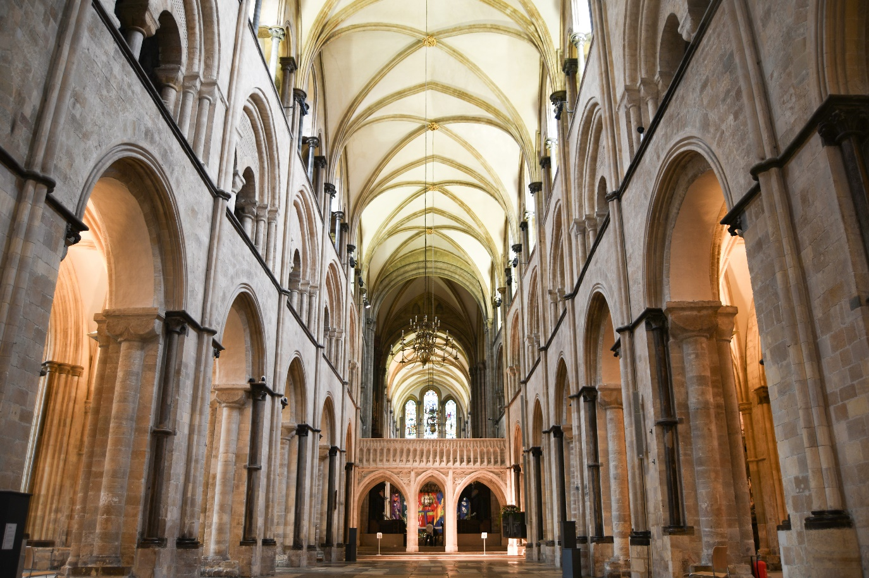
The Cathedral is a living church that has been at the centre of life in Chichester for over nine centuries. We are a place of worship and mission, the Mother Church of the Diocese of Chichester (which covers East and West Sussex) and the seat of the Bishop of Chichester. We are supported by a committed worshipping congregation, a small but dedicated staff team and over 400 volunteers.  The Cathedral is a leading visitor attraction, a venue for artistic and cultural activity, and an all-round hub for the community, welcoming over 250,000 visitors each year. Music is a central element in the Cathedral’s life. The Choir, which offers eight sung services each week and contributes to the Cathedral’s outreach around the diocese, has a high reputation at national and international level. We also host many high-quality musical performances each year by choirs, orchestras and chamber groups. | The Cathedral presents a comprehensive events programme and has a trading subsidiary, Chichester Cathedral Enterprises Ltd (CCEL), offering hospitality and retail services that support the Cathedral in delivering its mission. We have both a residential and commercial property portfolio many of them listed, in the Cathedral Close and beyond.  The Cathedral does not receive statutory or Church of England funding and is self-supporting, relying on self-generated income, donations, and fundraising activities. The Chapter is supported by the Chichester Cathedral Restoration & Development Trust and the Friends of Chichester Cathedral.  Further information about Chichester Cathedral can be found on the Cathedral website, including our Annual Report & Accounts.

Our Vision
The Cathedral’s anniversary in 2025 invited us to think more deeply about our purpose here in Chichester – in our worship, in our teaching, in our common life, in our commitment to diversity and inclusion and in our mission.
Invoking the prayers of St Richard, we have been drawn to that vein of spiritual renewal that animated the Latin West and especially this diocese in the thirteenth century – that is, the spirituality of St Dominic, which formed Richard and which shaped his own ministry here in Sussex, not least in resourcing his own pastoral care, teaching ministry, and expansion of the Cathedral’s life.
We’ve therefore taken inspiration from Dominican life in the so-called ‘Four Pillars’: Prayer, Study, Community and Mission. In these we begin to see a pattern of common life that helps us to fix our eyes on Christ as a means to becoming more prayerful; wiser in our understanding of what it means to be Christlike in the 2020s; becoming a community that is compassionate and joyful; and becoming more courageous in our mission and service to the world.
We hope you find inspiration and challenge in this pattern of life that we are setting before the Cathedral community and ask for your prayers as we seek to build up the household of faith here.

Prayer  Committing ourselves to seeking the face of God afresh in contemplation and worship, we hope to be guided by The Spirit to enter more deeply into the mystery of Jesus Christ and to radiate His beauty. | Study  Rooted in prayer, we seek to discern what it means to be human in an age of technological, political, social and economic change – through study, teaching and engagement with the World.
Community  Shaped by the insights of prayer, contemplation and study, we seek to build up our community in love, compassion and hospitality – encouraging each other to step out in faith and hope. | Mission  As a discerning, prayerful and loving community, we seek to take the message of God’s grace into the World with imagination, beauty and confidence, radiant with the promise of salvation.

You can read our full Vision document on the Cathedral website.

Commitment to Safeguarding
In accordance with Church of England’s policy, Promoting a Safer Church and the House of Bishops’ Safeguarding Policy and Practice Guidance, Chichester Cathedral is committed to the safeguarding of children, young people, and vulnerable adults who may be at risk.
The Cathedral works in partnership with the Diocese of Chichester to ensure that we operate in accordance with best practice at all times.
The care and protection of children, young people and vulnerable adults are the responsibility of the whole Cathedral community, whether clergy, staff, volunteers, contractors or members of the congregations. Everyone who participates in the life of the Cathedral has a role to play in promoting a safe environment for all.
To learn more about Safeguarding at the Cathedral please see our website.

Commitment to Equality & Diversity
At Chichester Cathedral we are dedicated to encouraging a supportive and inclusive workplace culture amongst our employee and volunteer workforce. It is our aim to ensure that if you work here or apply to work here, on either a paid or voluntary basis you will have an equal opportunity. We are also committed to working towards an organisation workforce that is diverse and as representative of our wider community as it can be.
We respect and value each of our employees and volunteers and are committed to enabling you to be able to perform to the best of your abilities and to be your authentic self in the workplace.

About the Role

JOB DESCRIPTION

Job Title: | Liturgy & Music Co-ordinator
Team: | Liturgy & Music
Location: | Cathedral Offices
Line Manager: | Liturgy & Music Manager
Contract type: | Permanent
Hours: | Part time 0.8 (to be worked over 5 days, usually Monday-Friday)
Date of completion: | May 2024

1 | Job Purpose
 | To provide administrative support to the Liturgy & Music team of Chichester Cathedral.
2 | Principal Accountabilities
- Provide administrative support for the Liturgy and Music team, supporting the Precentor, Liturgy and Music Manager and Organist in the arrangements for services and concerts taking place in the Cathedral, including occasional liaison with external organisers;
- In liaison with the Liturgy and Music Manager and/or the Head of Marketing, to oversee the in-house printing process for a wide variety of printed material (including service booklets, news sheets, music listings and concert programmes), as well as overseeing maintenance of printers in liaison with contract suppliers and ordering of supplies;
- Undertake administration for visiting choirs programme, including safeguarding checks and record keeping, pro-active work to fill vacancies, and management of the Cathedral diary;
- Undertake administration for the Lunchtime Concert series, including preparation of programmes, liaison with performers, and management of the Cathedral diary;
- Undertake administration relating to the Cathedral College of Canons and Electoral/Community Rolls;
- Maintenance of printing machines in liaison with contract suppliers;
- Acts as liaison point for the Cathedral congregation for courses and events, and first point of contact for enquiries regarding life events (baptisms, weddings, funerals.
3 | Level of Responsibility
a | People  The post holder does not have direct management responsibilities but may be required to manage volunteers.
b | Financial Management  The post holder does not have any budgetary responsibility but will be required to understand budgetary principles and provide input as appropriate.
4 | Contacts
Working internally with colleagues including employees, clergy and volunteers and the wider Cathedral congregation.

Working externally with musicians and other contacts.

5 | Special Requirements
- Chichester Cathedral is a living church and applicants should be in sympathy with our Christian mission.
- All our employees are required to undertake mandatory training including CofE safeguarding training as appropriate;
- The post holder will work primarily from the Cathedral offices in Chichester, though there is some scope to work remotely by arrangement;
- There may be occasional out-of-hours/weekend working, with time off in lieu.

6 | Qualifications, Skills and Experience
Qualifications
GNVQ level 3 or equivalent

Skills
- Intermediate Microsoft Office user
- Able to us Microsoft Access
- Broad knowledge of, and interest in, music.

Experience
- Previous administrative experience would be advantageous;
- Experience of working in a church or cathedral setting and an understanding of the Church of England’s services and structures would be desirable.

How to apply

You are required to complete an application form, available on our website: here

Please email your completed application to: Val Timlin, our Head of HR at:
hr@chichestercathedral.org.uk

- The closing date for applications midnight on Wednesday 3 July 2024.
- Interviews will take place in Chichester on Thursday 11 July 2024.

If you wish to have a discussion about this role with Richard Paterson, the Liturgy & Music Manager, please email him, to arrange a convenient time to talk, at:
richard.paterson@chichestercathedral.org.uk

Any questions?
Head of HR, Val Timlin
hr@chichestercathedral.org.uk

